AWS Task 4
1. Launch an EC2 instance (Linux and Windows) along with a web server.

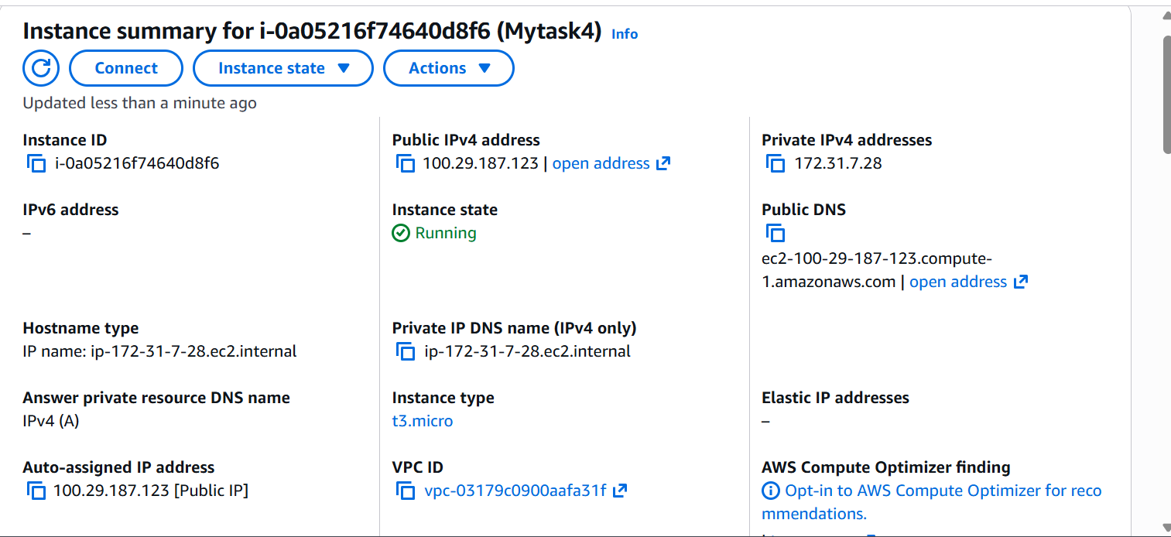
2. Connect with two web servers.
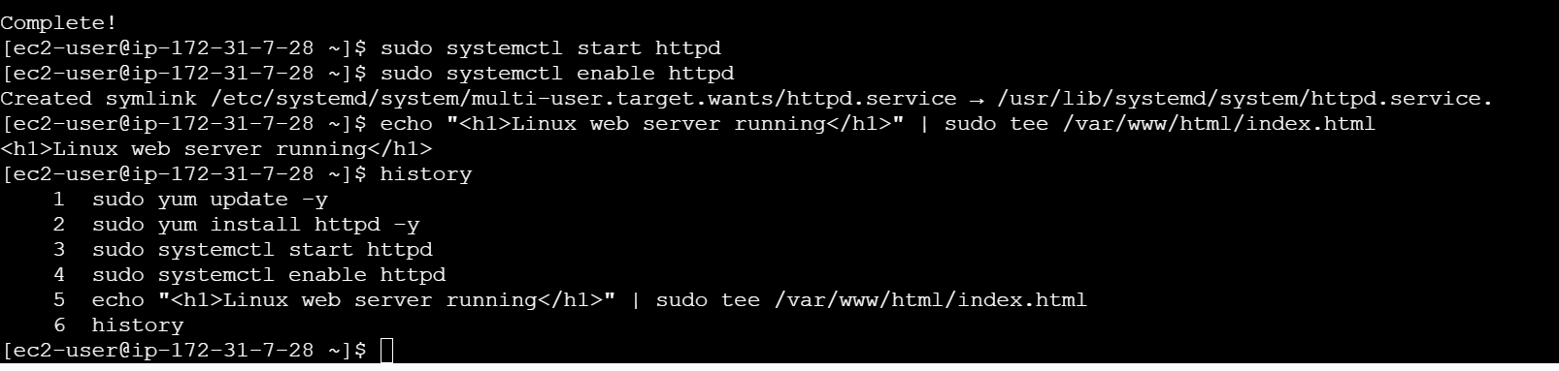
3. create an EBS volume of 5 GB, attach it to an EC2 machine (Linux and Windows),
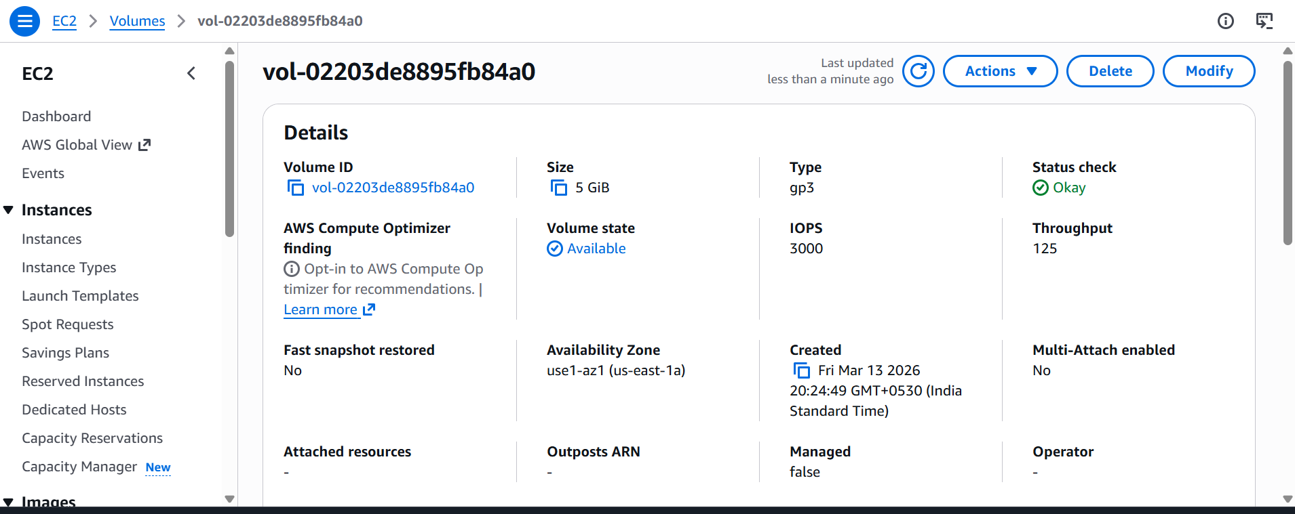

4. Finally, create an EBS volume using the taken snapshot.

